Introduction to Software Design & Analysis (SDA)
Purpose: Study of principles, methods, and practices for designing, analyzing, and developing software systems, focus on solving real-world problems using systematic approaches.

What is a System: Systems solve problems, organized approach for handling issues, consist of three components: input, processing, output.

Types of Systems
- Application Program (Computer App): software performing coordinated functions, tasks, or activities for users,
- Information System: software organizing and analyzing data, answering questions, solving organizational problems.

Software Design: Process of identifying system objects, their relationships, designing models convertible to executables using OO languages,
Goal: Build a model meeting customer requirements, ensuring successful implementation.

Importance of Software Design
- Larger, complex, distributed systems require structured architecture,
- Any software needs overall architectural design guiding construction and development.

Responsibility for Design & Architecture
- Derived from system requirement specifications, analysis models,
- Developed by software architects, designers,
- Process involves mapping system requirements to architecture design, applying strategies to manage complexity, resolve architecture.

Importance of Software Architecture
- Poor design → product fails requirements, lacks adaptability, reusability, predictable behavior,
- Without proper planning → inefficient production, wasted time, higher costs.

Defining the Problem: Critical stage, unclear problem definitions → flawed systems, misaligned requirements.

Software Crisis: Increasing complexity, cost overruns, delays, low-quality software due to inadequate planning, analysis, design.

Why Object-Oriented Design: Simplifies modeling, enables modular, reusable, flexible software architecture aligning with real-world concepts.

What is a Model: simplification of reality, abstraction aiding understanding,

Examples: miniature bridge for real bridge, mental models simplifying perception,

Purpose: understand needs, communicate understanding, detect commonalities, differences, misunderstandings.

Object-Oriented Programming (OOP): Paradigm creating objects containing data, methods, combining functionality and structure,
Advantages:

Modularity: divides systems into manageable objects,

Reusability: reuse objects across projects,

Flexibility: easy changes, minimal code impact,

Readability: clear, maintainable, well-structured code.

Basic OO Concepts
Objects: basic components performing small, specific tasks, representing system components,
Object Types:
- GUI Objects → user interface elements (buttons, labels),
- Problem Domain Objects → business logic elements (order-entry system, payroll system).

Classes vs Objects
- Class: blueprint defining properties, behavior of objects,
- Object: instance of a class, inherits variables, methods, models real-world entities.

OOP Principles

Abstraction
- Hiding implementation details, exposing functionality only,
- Deals with “what it does” not “how it does,”
- Achieved via abstract classes, interfaces,
- Examples: Car controls, smartphone UI, online shopping checkout,
- Code Readability: Focus on essentials, user-friendly, simplified system view.

Encapsulation
- Wrapping data, methods into single unit, restricting direct access,
- Ensures data security, modularity, maintainability,
- Examples: Banking systems securing account details, smartphones encapsulating hardware interactions.

Inheritance
- One class inherits properties, methods from another using extends,
- Advantages: Code reusability, modularity, automatic updates to subclasses,
- Examples: Animal → Mammal, Bird, Car → Vehicle hierarchy.

Polymorphism
- Performing tasks in multiple ways, enables method overriding, overloading,
- Types:
  - Compile-time polymorphism → method overloading,
  - Run-time polymorphism → method overriding.
Examples: Delivery methods, shapes drawing, payment processing, animal sounds.
- Advantages: Simplified, flexible, reusable code handling multiple object types seamlessly.

Software Development Life Cycle (SDLC)
Organizational process for system development, mixture of activities:
- System Study,
- Feasibility Study,
- System Analysis,
- System Design,
- Coding,
- Testing,
- Implementation,
- Maintenance.

System Study
- Stage 1 of SDLC,
- Initial survey → scope identification,
- In-depth study → requirements, limitations analysis,
- Proposal prepared by System Analyst → findings, recommendations,
- Steps: Problem identification, project initiation, background analysis, inference, findings.

Feasibility Study
- Test proposed system for workability, user requirements, cost-effectiveness,
- Types:
  - Technical feasibility,
  - Operational feasibility,
  - Economic feasibility (cost/benefit),
  - Schedule feasibility.

System Analysis
- Detailed study of current system, operations, interactions,
- Data collection using interviews, questionnaires, observations,
- Define system boundaries, document analysis via DFDs, data dictionaries, logical structures.

System Design
- Based on requirements, analysis results,
- Stages: Preliminary (general) design, Detailed (structured) design,
- Activities: database design, input/output design, program design, detailed component specifications.

Coding
- Convert procedures into computer language,
- Programs → coordinate data movements, control processes,
- Must be modular for faster development, maintenance, scalability.

Testing
- Ensure bug-free system before implementation,
- Test types:
  - Unit testing → individual program verification,
  - Integration testing → combined program testing,
  - System testing → interaction with other systems.

Implementation
- Load programs onto user systems,
- Train users on execution, data entry, processing, report generation,
- Strategies:
- Parallel run → manual + computerized comparison,
- Pilot run → partial system deployment before full rollout.

Maintenance
- System reviews for performance, capabilities, change requirements,
- Major changes may require new project cycles through all phases.
- Types
  - Corrective Maintenance: Fixing errors or defects in the system after it goes live.
  - Adaptive Maintenance: Updating the system to work with new environments (e.g., OS updates, hardware changes).
  - Perfective Maintenance: Improving performance, usability, or adding new features to enhance the system.
  - Preventive Maintenance: Making changes to prevent potential future issues or system failures.

System Environments: Development, Test, Staging, Pre-Production, Production, Mirror environments supporting software lifecycle stages.

Roles Involved: Developer, Development Manager, Project Manager, Test Manager, Configuration Manager, Deployment Team.

Processes and Models

Process: A high-level framework defining who, what, how, when for software development. A sequence of steps defined in an order to complete a task.

What is a Process Model: A process model defines the tasks to be performed, their sequence, conditions for execution, and the roles responsible for achieving the desired results.

Why Process Model
- Provides guidance for systematic coordination
- Controlling tasks
- Controlling personnel performing tasks
- Key terms → coordination, control, tasks, people

Common Activities of Process Model
- Specification → define system requirements
- Design & Implementation → organize, implement system
- Validation → check system meets customer needs
- Evolution → modify system for changing requirements

Plan-Driven vs Agile Development
- Plan-Driven → a structured, staged approach where requirements and outputs are planned upfront with limited flexibility for change, not necessarily waterfall, can be incremental, iteration within activities possible
Agile → an adaptive, iterative, and incremental approach where specification, design, coding, and testing are interleaved with continuous stakeholder feedback.
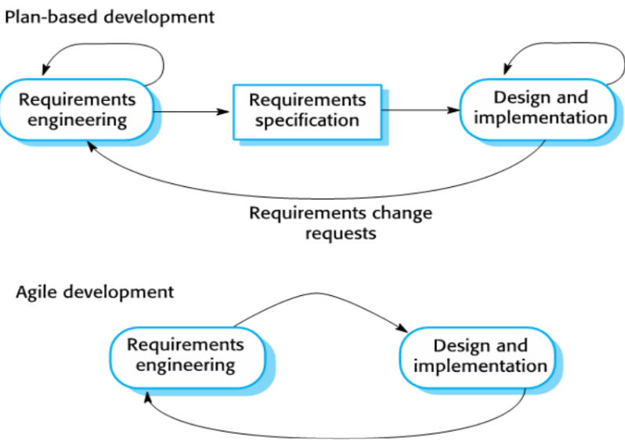

Generic Process Flows
- Linear Process Flow: Each phase completed once in sequence; no overlap or backtracking. Plan-driven (e.g., Waterfall model). Change is very late
- Iterative Process Flow: System developed through repeated cycles, refining after each iteration. Change-driven (e.g., Prototyping, Spiral model)
- Incremental Process Flow: System built in small deliverable parts, each adding functionality until complete. Can use both: Plan-driven for predefined increments, Change-driven for evolving needs.
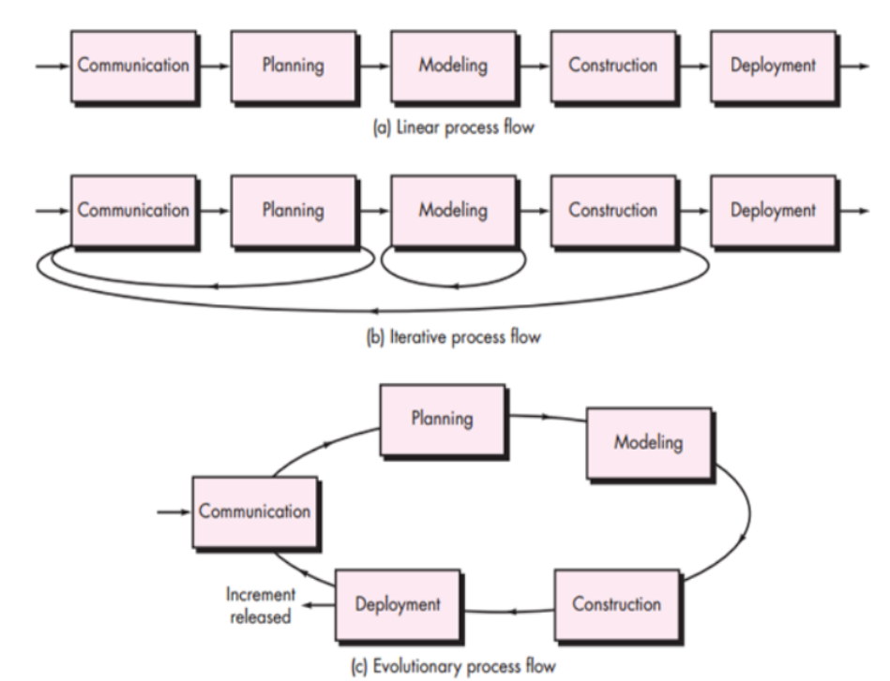

Waterfall Model
- Requirements specified
- Four main tasks in sequence → Analysis, Design, Code, Test
- Followed by Integration
- Output of one stage feeds into next
- Pros → simple, easy to understand, suitable for small, well-defined projects
- Cons → no working product until end, inflexible, difficult to handle changes

Incremental Model
- Each major requirement developed separately → requirement, design, code, unit test
- Pieces merged into integrated system test
- Pros → quick working software, flexible, less costly, easier testing/debugging, customer feedback after each build
- Cons → requires good planning, clear definition of entire system

Iteration Model
- Divides development into repeated cycles (planning, risk analysis, engineering, evaluation).
- Emphasizes evolutionary development through prototypes and refinements.
- Strong focus on formal risk analysis and stakeholder feedback at each iteration.
- Refinement until goals met
- Pros: Adapts well to changing requirements, identifies risks early, ensures continuous customer feedback.
- Cons: Costly and time-consuming, requires skilled risk analysis, complex to manage.

Rapid Software Development
- Focus on rapid development and delivery,
- Needed due to fast-changing requirements,
- Stable requirements often impossible,
- Software must evolve quickly with business needs,
- Plan-driven approaches insufficient for dynamic business needs
- Agile methods introduced in late 1990s for faster delivery

Agile Software Development Characteristics
- Specification, design, implementation interleaved
- System built in versions/increments with stakeholder (directly or indirectly involved with the system) involvement,
- Frequent delivery of versions for feedback
- Automated testing tools used
- Minimal documentation, focus on working code
- Agile uses UML as a sketch, direct work
- Agile Models:
  - XP (Extreme Programming) → Focuses on technical practices: pair programming, test-driven development, continuous integration.
  - Scrum → Focuses on project management side: sprints, roles, events, artifacts. Scrum sprint cycle: Iterative + incremental, time-boxed development cycles delivering increments

Unified Process Model (UP)
- Introduced 1997 for object-oriented software engineering
- Iterative, incremental, risk-driven
- Combines spiral and evolutionary models
- 2D process → phases and workflows
- Uses Miller’s Law: People can process and remember about 7 ± 2 pieces of information at a time.

Unified Process
- Extensible framework customized for organizations/projects
- Rational Unified Process (RUP) → variant widely used
- UP and RUP terms often interchangeable

Unified Process Building Blocks
- used to describe what should be produced, who is in charge of producing it, how production will take place, and when production is complete.
- Workers → ‘Who’, roles with responsibilities
- Activities → ‘How’, units of work creating/updating artifacts
- Artifacts → ‘What’, tangible outputs like code, documents, models
- Workflows → ‘When’, sequence of activities producing observable value

Phases and Workflows of UP
- Phase → business context
- Workflow → technical context

UP Phases
- Inception Phase → Establish approximate vision, define scope, prepare rough estimates, assess feasibility, identify initial business case, risks, and use cases, about 10% of requirements identified.
- Elaboration Phase → Refine vision and requirements, implement and validate core architecture iteratively, resolve high-risk elements, gain deeper understanding of problem and solution space, code/test critical units, about 80% of requirements identified with realistic estimates.
- Construction Phase → Iterative development of remaining lower-risk and easier components, complete programming and testing, produce beta versions and initial manuals, prepare system for deployment.
- Transition Phase → Conduct beta tests, finalize and deliver system, deploy into operating environment, provide final artifacts and user manuals, ensure smooth handover to end users.

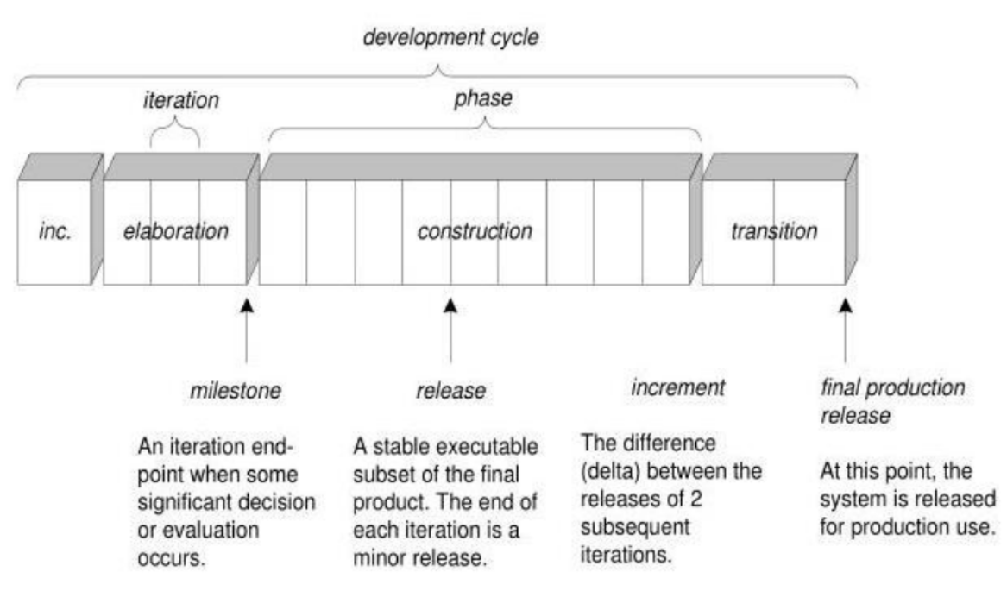

Goals & Features of Each Iteration
- Reduce performance, integration, conceptual risks
- Mini-waterfall approach per iteration
- Each iteration delivers incremental improvement and is risk driven
- Risk-driven development focus

Advantages of UP
- Addresses high risks early
- Requirements refined during project
- Less document-heavy
- Emphasis on product quality

UP Best Practices
- Prioritize high-risk/high-value features
- Continuous user feedback
- Early cohesive architecture
- Frequent realistic testing
- Use cases where needed
- Visual UML modeling
- Manage requirements, change requests, configuration

Example Roles in UP
- Stakeholder → customer, product manager
- Software Architect → maintains architectural vision
- Process Engineer → defines/refines development process
- Graphic Artist → assists with UI design

Planning Types:

Risk-Driven Planning
- Identify, mitigate high risks first
- Focus on architecture-centric iterative development
- Stabilize core architecture early

Client-Driven Programming
- Prioritize features most important to client
- Visible progress with each iteration

Planning Workflow
- Define project scope
- Define next iteration scope
- Identify stakeholders
- Capture expectations
- Build team
- Assess risks
- Plan iteration/project work
- Develop closure criteria
- UML diagrams for initial business model, class diagrams

Unified Modeling Language (UML)
- Language for specifying, visualizing, constructing, documenting software artifacts
- Supports business modeling
- Visual representation focus

Ways to Apply UML
- UML as Sketch → rough diagrams for understanding
- UML as Blueprint → detailed design diagrams
- UML as Programming Language → precise specifications for code generation

Perspectives to Apply UML
- Conceptual perspective
- Specification (software) perspective
- Implementation (software) perspective

Class in Different Perspectives
- Conceptual class: Represents real-world concepts or objects in the problem domain.
- Specification class: Defines the structure and behavior (attributes, operations) without implementation details.
- Implementation class: The actual code-level representation of the class in a programming language.

Agile Modeling Emphasis
- Simplicity
- Communication
- Feedback
- Courage
- Iterative modeling practices

UML and “Silver Bullet” Thinking
- Critical thinking on whether UML diagrams alone improve software quality
- Diagrams useful but not sufficient without good practices

Domain Modeling
- Domain modeling is the first step in object-oriented analysis and design, with the end goal of constructing classes for a software system. It helps identify relevant concepts and ideas of a domain.
- A domain model illustrates meaningful conceptual objects in a problem domain. It is a visual representation of real-world concepts like physical objects, events, or transactions.
- A domain model contains conceptual classes, attributes (a need to remember information), associations, and multiplicity. It does not include operations/functions, software classes, or software responsibilities. A domain model is not a software artifact.
- The steps to create a domain model are:
  - Create User Stories, which are one or more sentences in the end user's language that capture what a user does or needs to do.
  - Identify candidate conceptual classes. This can be done by identifying nouns and noun phrases in the domain description.
  - Draw them in a UML domain model.
  - Add associations to record relationships.
  - Add attributes necessary to preserve information.
  - Use existing names from the domain.
- Associations are relationships between classes.
- Multiplicity indicates how many instances can be associated with another instance. Attributes should typically be "primitive" data types like numbers or strings, not complex domain concepts

High Priority Associations
Use high-priority associations when a relationship is strong and necessary. These include cases where:
- A is a physical or logical part of B.
- A is physically or logically contained in/on B.
- A is recorded in B.

To Avoid
- Showing redundant or derivable associations.
- Overwhelming the domain model with associations that are not strongly required.
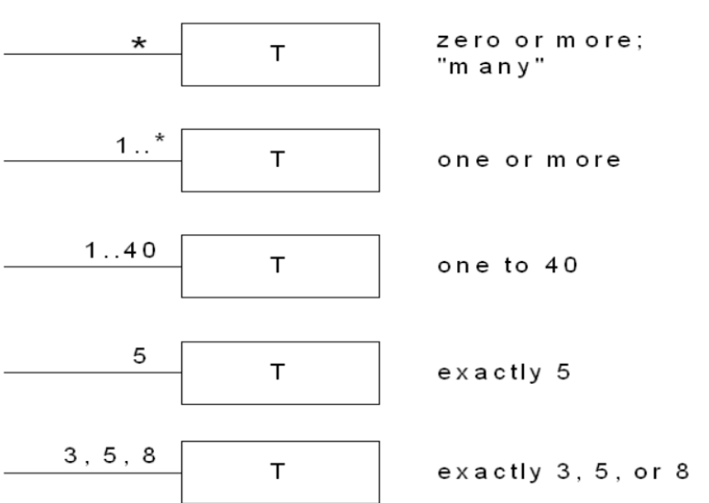
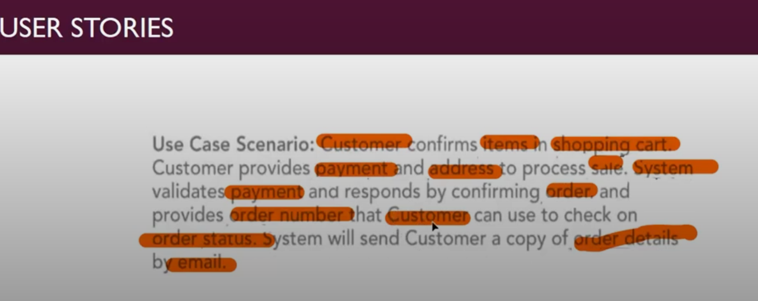
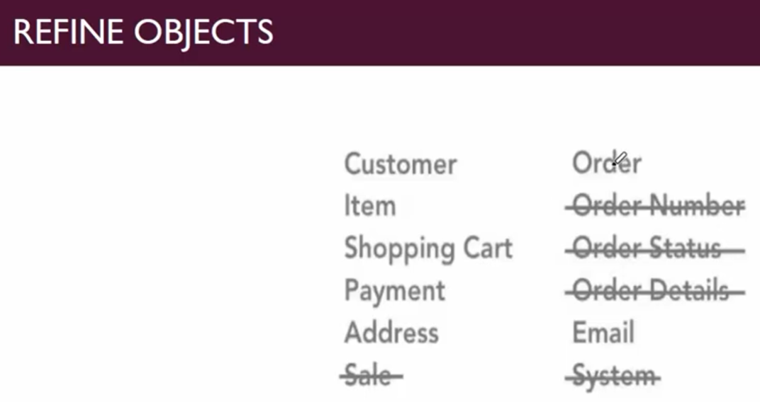
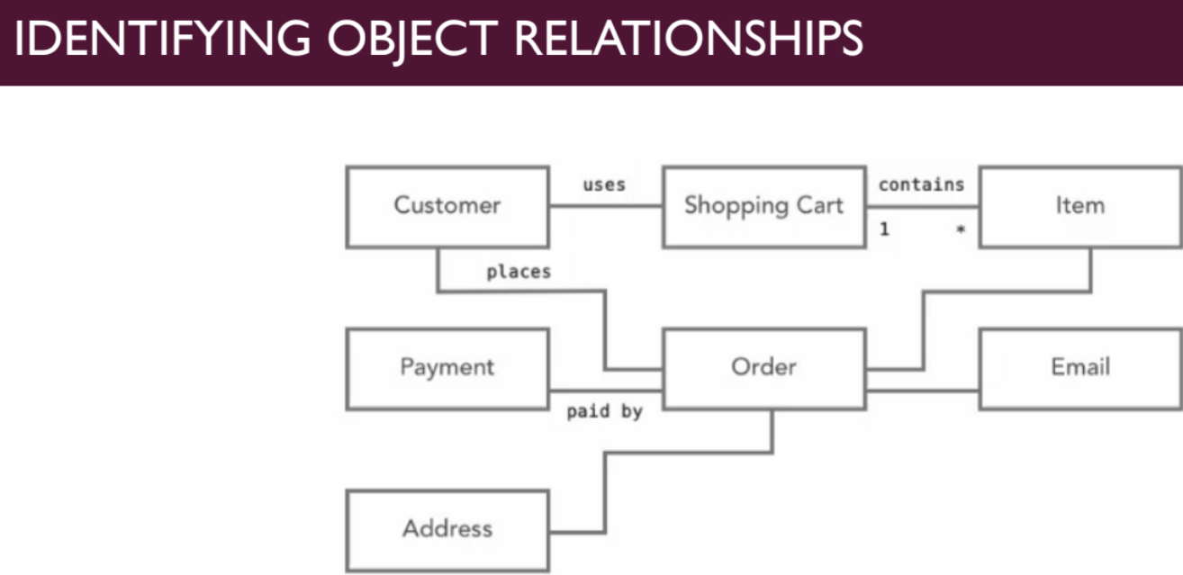
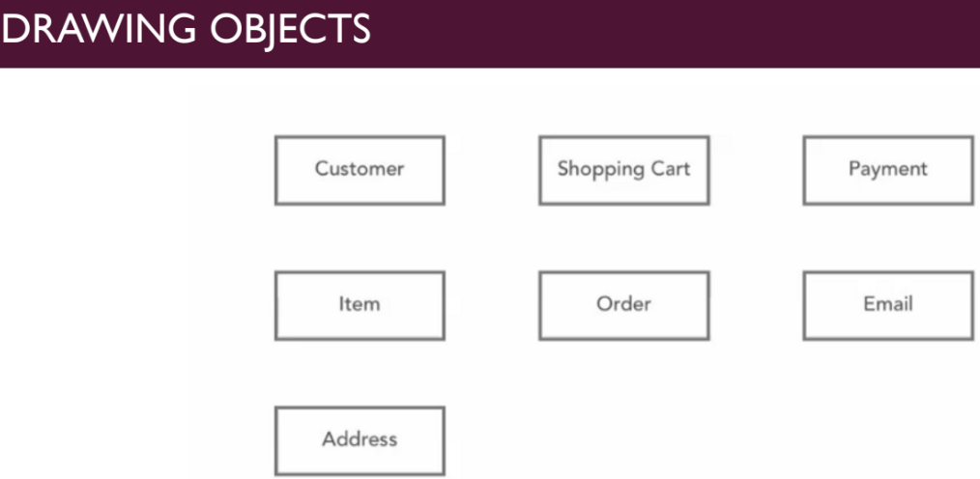

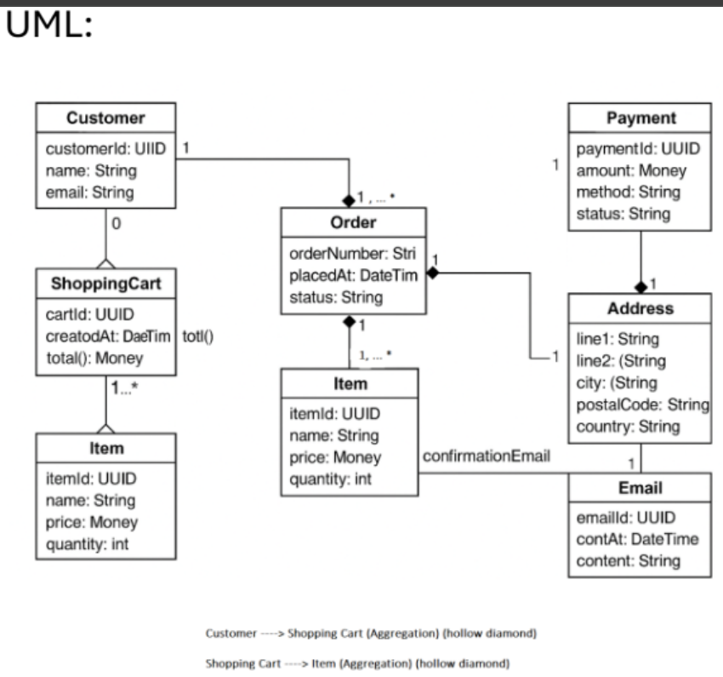

CHAPTER 3: UP AND UML

Inception Phase (First Phase of UP)
- Initial short step, establish vision and basic scope,
- Analyze ~10% of use cases, analyze critical non-functional requirements,
- Create business case, prepare development environment,
- One-line: Envision scope, vision, business case,
- Main problem solved: Do stakeholders agree on vision, is project worth serious investment?,
- Key artifacts → initial domain model, business model, requirements artifacts, analysis artifacts, preliminary architecture, initial risk list, initial use case ordering, initial business case, plan for elaboration.
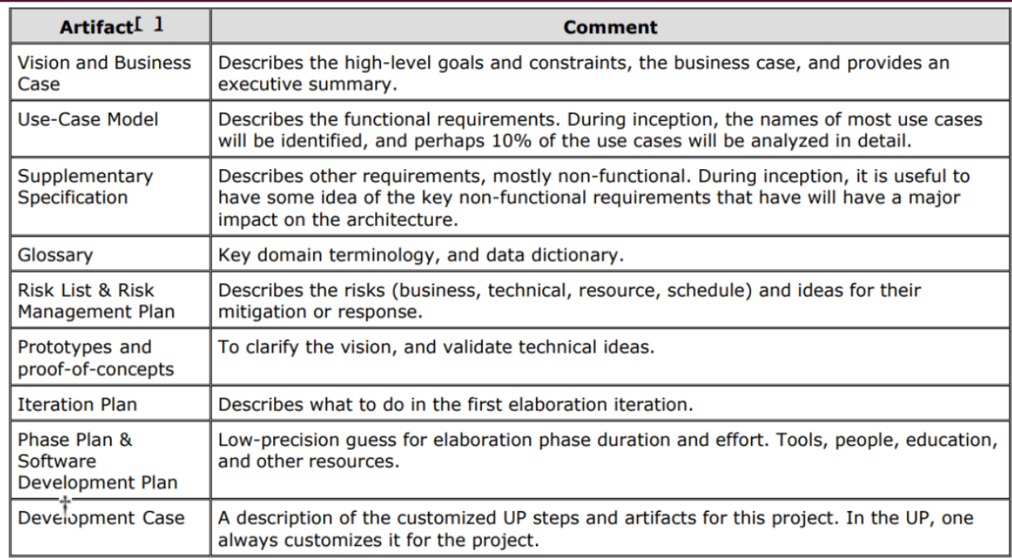
Requirements
- Requirement: Statement of service, constraint, or function, may be abstract or detailed,
- User Requirements: Written for customers, natural language, non-technical,
- System Requirements: Written for developers, detailed functional + non-functional specs, includes implementation details.

Stakeholders: are individuals or groups with an interest in the system, including end users, system managers, system owners, external stakeholders.

Types of Requirements
- Functional: are statements about the services the system should provide, how it should react to specific inputs, and what it should not do
- Non-functional: are constraints on the system's services or functions, such as timing, performance, or development process standards. They are similar to quality attributes and can be more critical than functional requirements. Unmet NFRs may render system useless.

Use Cases (Ivar Jacobson, 1994)
- Scenario-based technique in UML,
- Formal representation of functionality from user’s perspective,
- Shows how system interacts with environment,
- Use Case Diagram: set of use cases + actors + relationships.
- One-line definition: What will the system do?

Guidelines for Use Case Diagrams
- Begin with a verb (e.g., Generate Report), avoid open-ended names,
- Avoid showing communication between actors,
- Name actors in singular form, no personal names,
- Show only system functionality (no behavior/sequence),
- Unlike DFDs, sequence not shown

Components of Use Case Diagram
- Actors → people/systems providing or receiving information, may be human, system, device, timer, clock,
  - Primary Actor (active): User goals fulfilled via system (e.g., cashier), → helps find user goals,
  - Secondary Actor (passive): Provides service to system (e.g., payment service), → clarifies interfaces,
  - Offstage Actor: Has interest but not directly active (e.g., tax agency), → ensures all interests considered.
- Use Case → defines functionality, complete task from start to finish, describes actor-system interaction,
- Relationships → communication or structural links,
- Boundary → system limits, rectangle around use cases to show external interaction..

Relationships in Use Case Model

Relationship | Definition | Notation
Association | Communication between actor and use case, represented as a simple line, aka communicate association | Line (—)
Generalization (Actors) | Child actor inherits roles/properties of parent actor actor to actor (same as base) | Hollow triangle (▷) from child to parent
Generalization (Use Cases) | Child use case inherits structure, behavior, relationships of parent use case, use case to use case (same as base) | Hollow triangle (▷) from child to parent
Include | Base use case explicitly incorporates behavior of another use case, reusable/common functionality, one usecase cannot be used without calling another, use case to use case | <<include>> dotted arrow  From including to included  Include → Base/Including → Included/Extra.
Extend | Target use case extends behavior of source, adds optional behavior, use case to use case | <<extend>>  From extending to extended  Extend → Extra → Extended.

Generalization can always be replaced by Extend, but Extend cannot always be replaced by Generalization, because generalization is mandatory inheritance, while extend is optional behavior.

Actors, Scenarios, Use Cases
- Actor: Entity with behavior (person, system, org), e.g., cashier,
- Scenario: Specific sequence of actions/interactions (use case instance),
- Use Case: Collection of related success/failure scenarios supporting actor’s goal.

Difference between extend and generalization:
- Generalization → Child use case always inherits behavior/structure from parent (mandatory). (same as base)
- Extend → A use case optionally adds extra behavior to another under certain conditions. (only usecase to usecase)

Steps in Creating Use Cases
- Identify use cases,
- Draw system boundary,
- Place use cases in diagram,
- Identify actors, Identify any external entities that interact with, supply, use, or rely on the system, including external resources or legacy systems
- Add relationships.

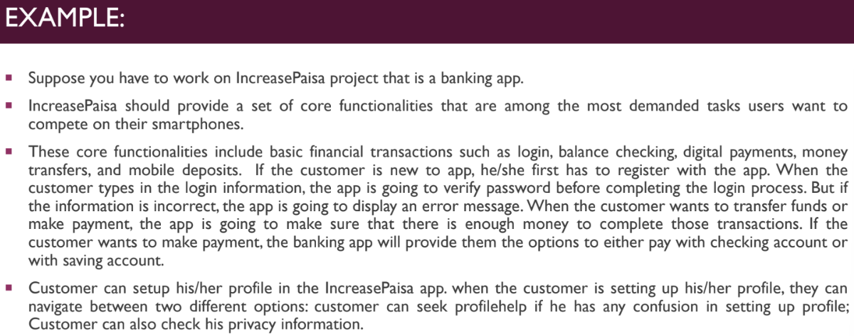

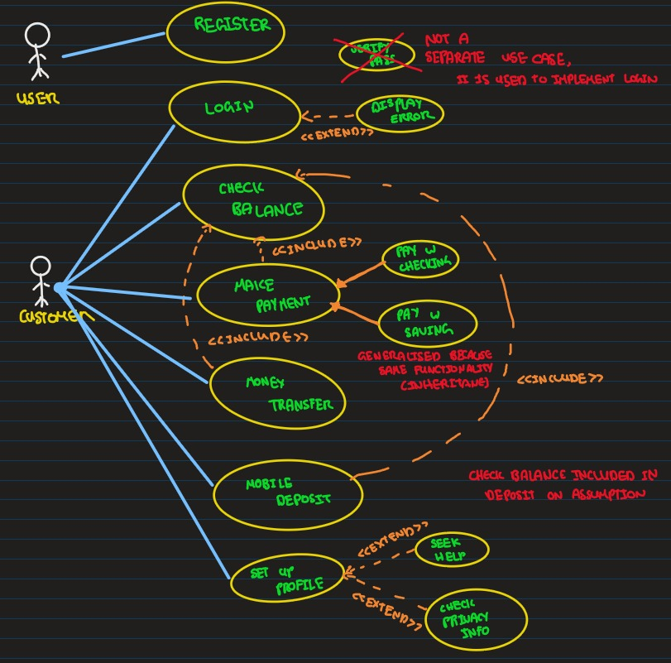

Types of Use Cases:
- Brief: A concise, one-paragraph summary of the main success scenario. Used for early requirements analysis to get a quick sense of scope.
- Casual: An informal, multi-paragraph format that covers various scenarios. Used for quick analysis.
- Fully Dressed: All steps and variations are detailed, with supporting sections like preconditions and success guarantees. These are written for a few architecturally significant use cases after many have been identified in brief format.

Elements of a Use Case:
- Name: A clear actor/verb/noun descriptor.
- Brief Description: A short paragraph on the scope of the use case.
- Actors: A list of users or systems that can interact with the use case.
- Preconditions: What must be true when the use case begins (e.g., customer must exist).
- Basic Flow: The main sequence of steps the actors and the system take to achieve the goal.
- Alternate Flows: Less common interactions or variations.
- Exception Flows: Things that prevent the user from achieving their goal (e.g., incorrect password).
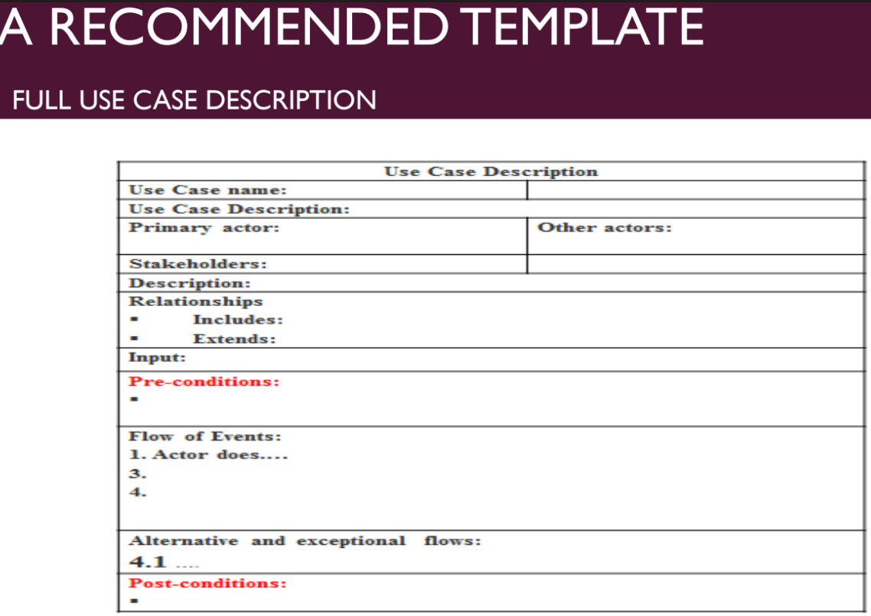
- Post Conditions: What must be true when the use case is complete (e.g., order is created).

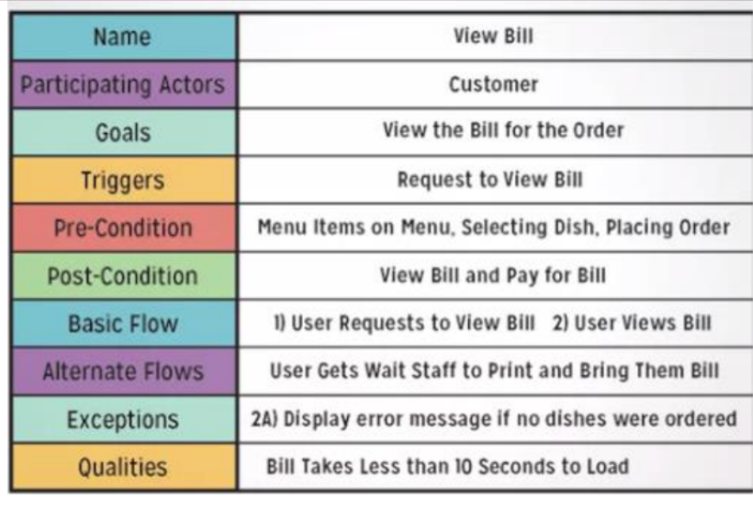

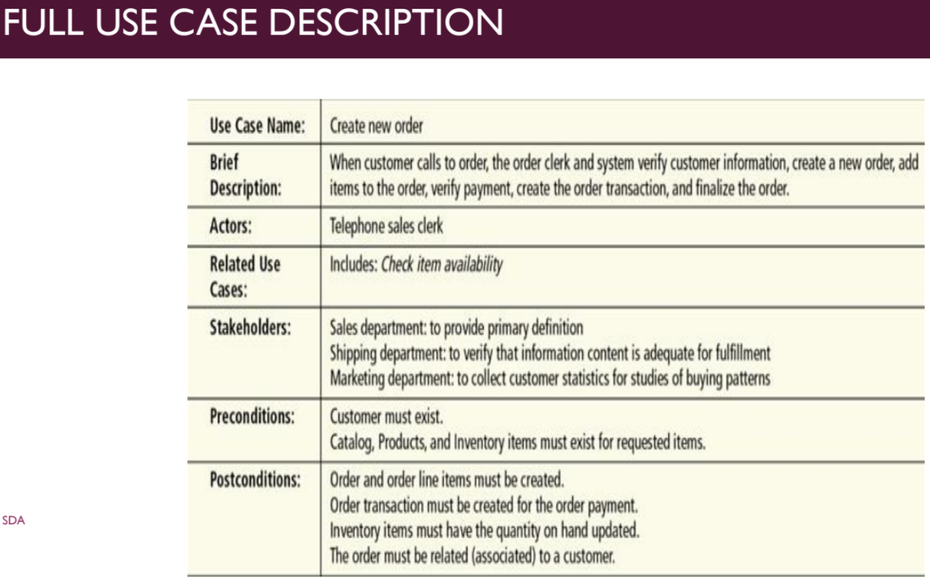
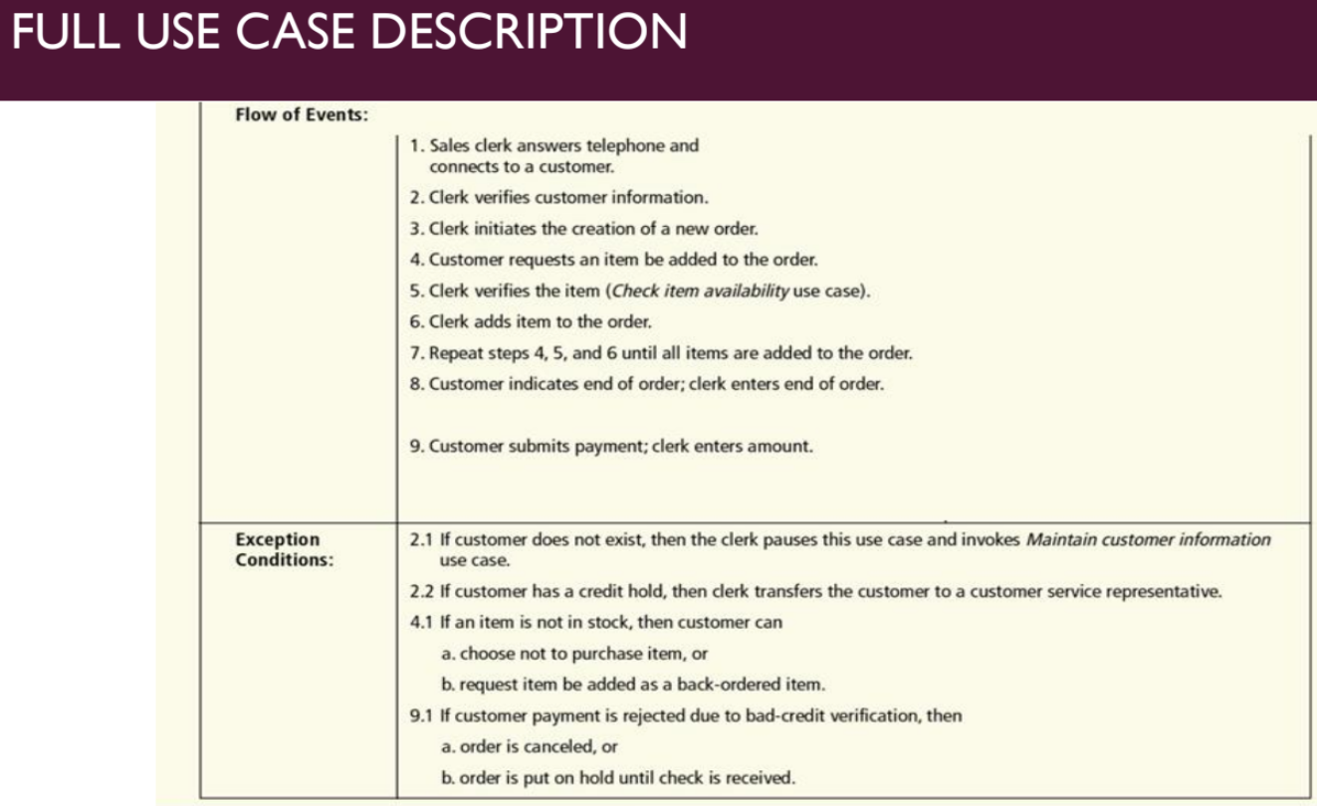

CHAPTER 4 CLASS DIAGRAMS

Object-Oriented Analysis and Design Phases and Uses
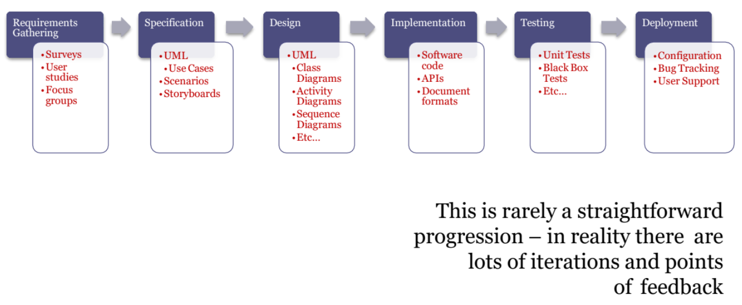

UML Diagrams
Structural Diagrams: These diagrams represent the data and static relationships in an information system. They show how different parts are connected to form the final design.
Behavioral Diagrams: These diagrams model the system based on its functionality.

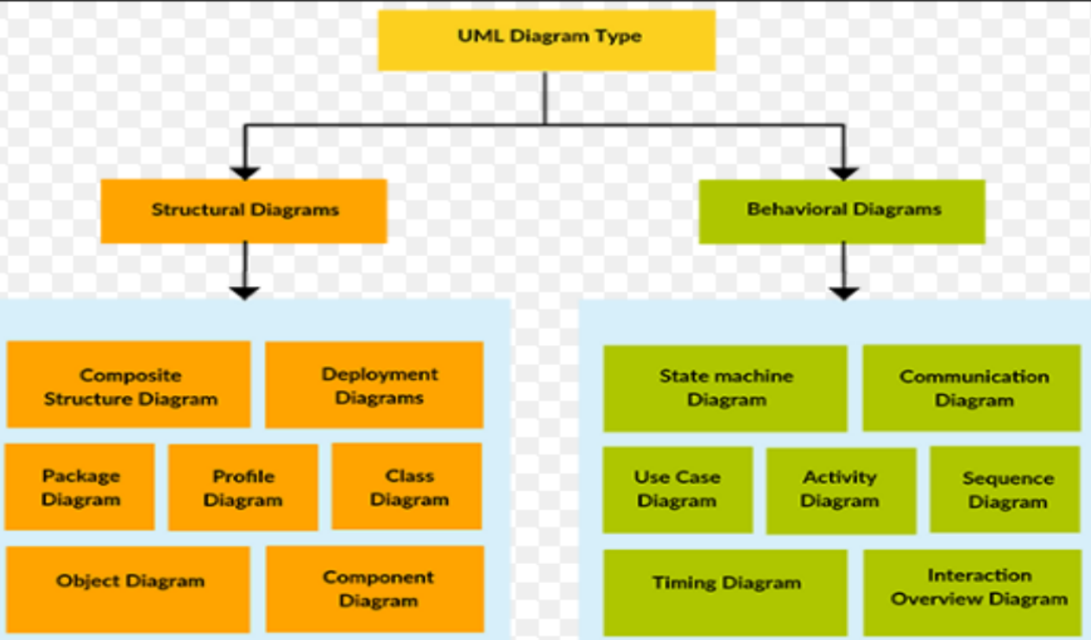

UML Class Diagram
A UML class diagram is a graphical representation of the system's business entities. Its aim is to convert the "what" of a system's requirements (from use cases) into the "how" for each requirement by breaking down use cases to form the basis for classes. A class diagram is composed of two primary elements: classes and class relationships
Class represents an entity in a system that provides an encapsulated implementation of certain functionality. Graphically, a class is a rectangle with three compartments: name, attributes, and operations.
- Class Name: The only required element in the graphical representation of a class, it is always in the top compartment.
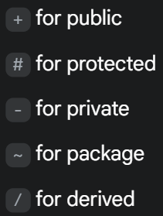
- Attributes: These are named properties that describe the object being modeled. They appear in the second compartment, below the class name. Attributes are typically listed as attributeName : Type.
  - Visibility (Access Specifiers): Attributes can have different visibility levels, indicated by symbols:
- Operations: These describe the class's behavior and appear in the third compartment. An operation's signature can be specified with its name, parameter list, and return type. The full UML syntax is visibility name(parameter-list) : return-type.
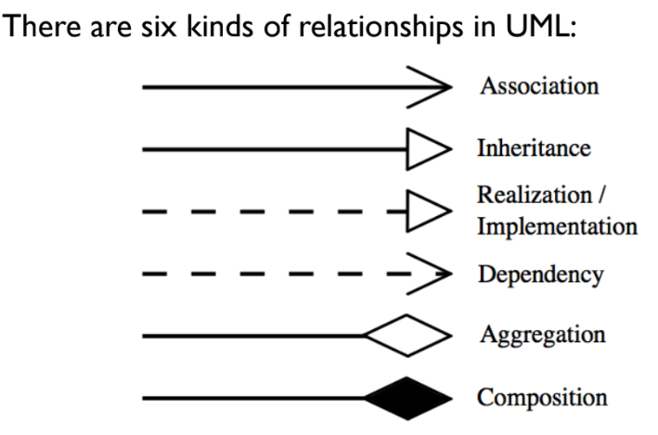
- Class Responsibilities: A class can also include its responsibilities, which are contracts or obligations to perform a particular service.
- In UML, object interconnections are modeled as relationships.

Dependency
A dependency indicates a semantic relationship where a change in one element affects another. It is represented when a reference to one class is passed as a method parameter to another. It is shown with a dashed line and an open arrowhead.

Generalization (Inheritance)
This relationship connects a subclass to its superclass. It denotes the inheritance of attributes and behavior and shows a specialization in the subclass. It is represented by a solid line with a hollow triangle pointing to the superclass.

Simple Association
An association is a link between two classes that need to communicate. It is represented by a line between the classes. There is no ownership.
- Multiplicity: This indicates how many objects are involved in the association. Symbols include:
  - *: 0, 1, or more
  - 1: exactly 1
  - 2..4: between 2 and 4, inclusive
  - 3..*: 3 or more
- Role Names: These specify the behavior or role of an object in the association.
- Kinds of Association:
  - One-way: Navigation is in a single direction, shown by an arrow towards the "server" object.
  - Two-way: Navigation is in both directions, shown by a simple line.
  - Self-association: A class has a relationship with itself.
  - Binary, Ternary, N-ary: Associations involving two, three, or more classes, respectively. A ternary association is shown with a diamond connected to the three classes.

Further Association Relations:
Aggregation (has a): This is a special kind of association that specifies a whole-part relationship. The key is that the part can exist independently from the whole. It is denoted by a hollow diamond adornment on the association line near having class.
Composition (owns): This is a stronger form of aggregation that indicates strong ownership and coincident lifetime. The parts "live and die as a whole". It is denoted by a filled diamond adornment near main class.
Realization: A realization relationship connects a class with an interface that provides its behavioral specification. It is rendered as a dashed line with a hollow triangle pointing to the interface (specifier)

Other Class Diagram Elements
- Parameterized Class (Template): A class that defines a family of potential elements. It is rendered as a small dashed rectangle in the upper right corner of the class rectangle.
- Packages: A container-like element for organizing other elements, such as classes. Packages can be used to control access between classes in different packages.
- Enumerations: A user-defined data type with a name and an ordered list of literals.
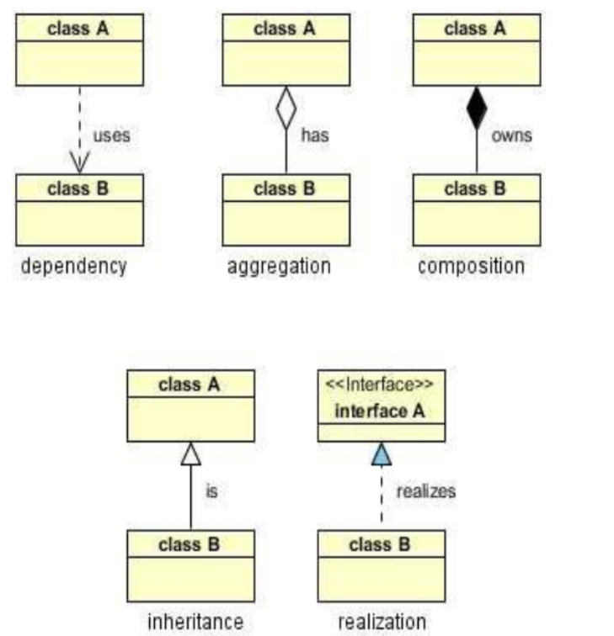
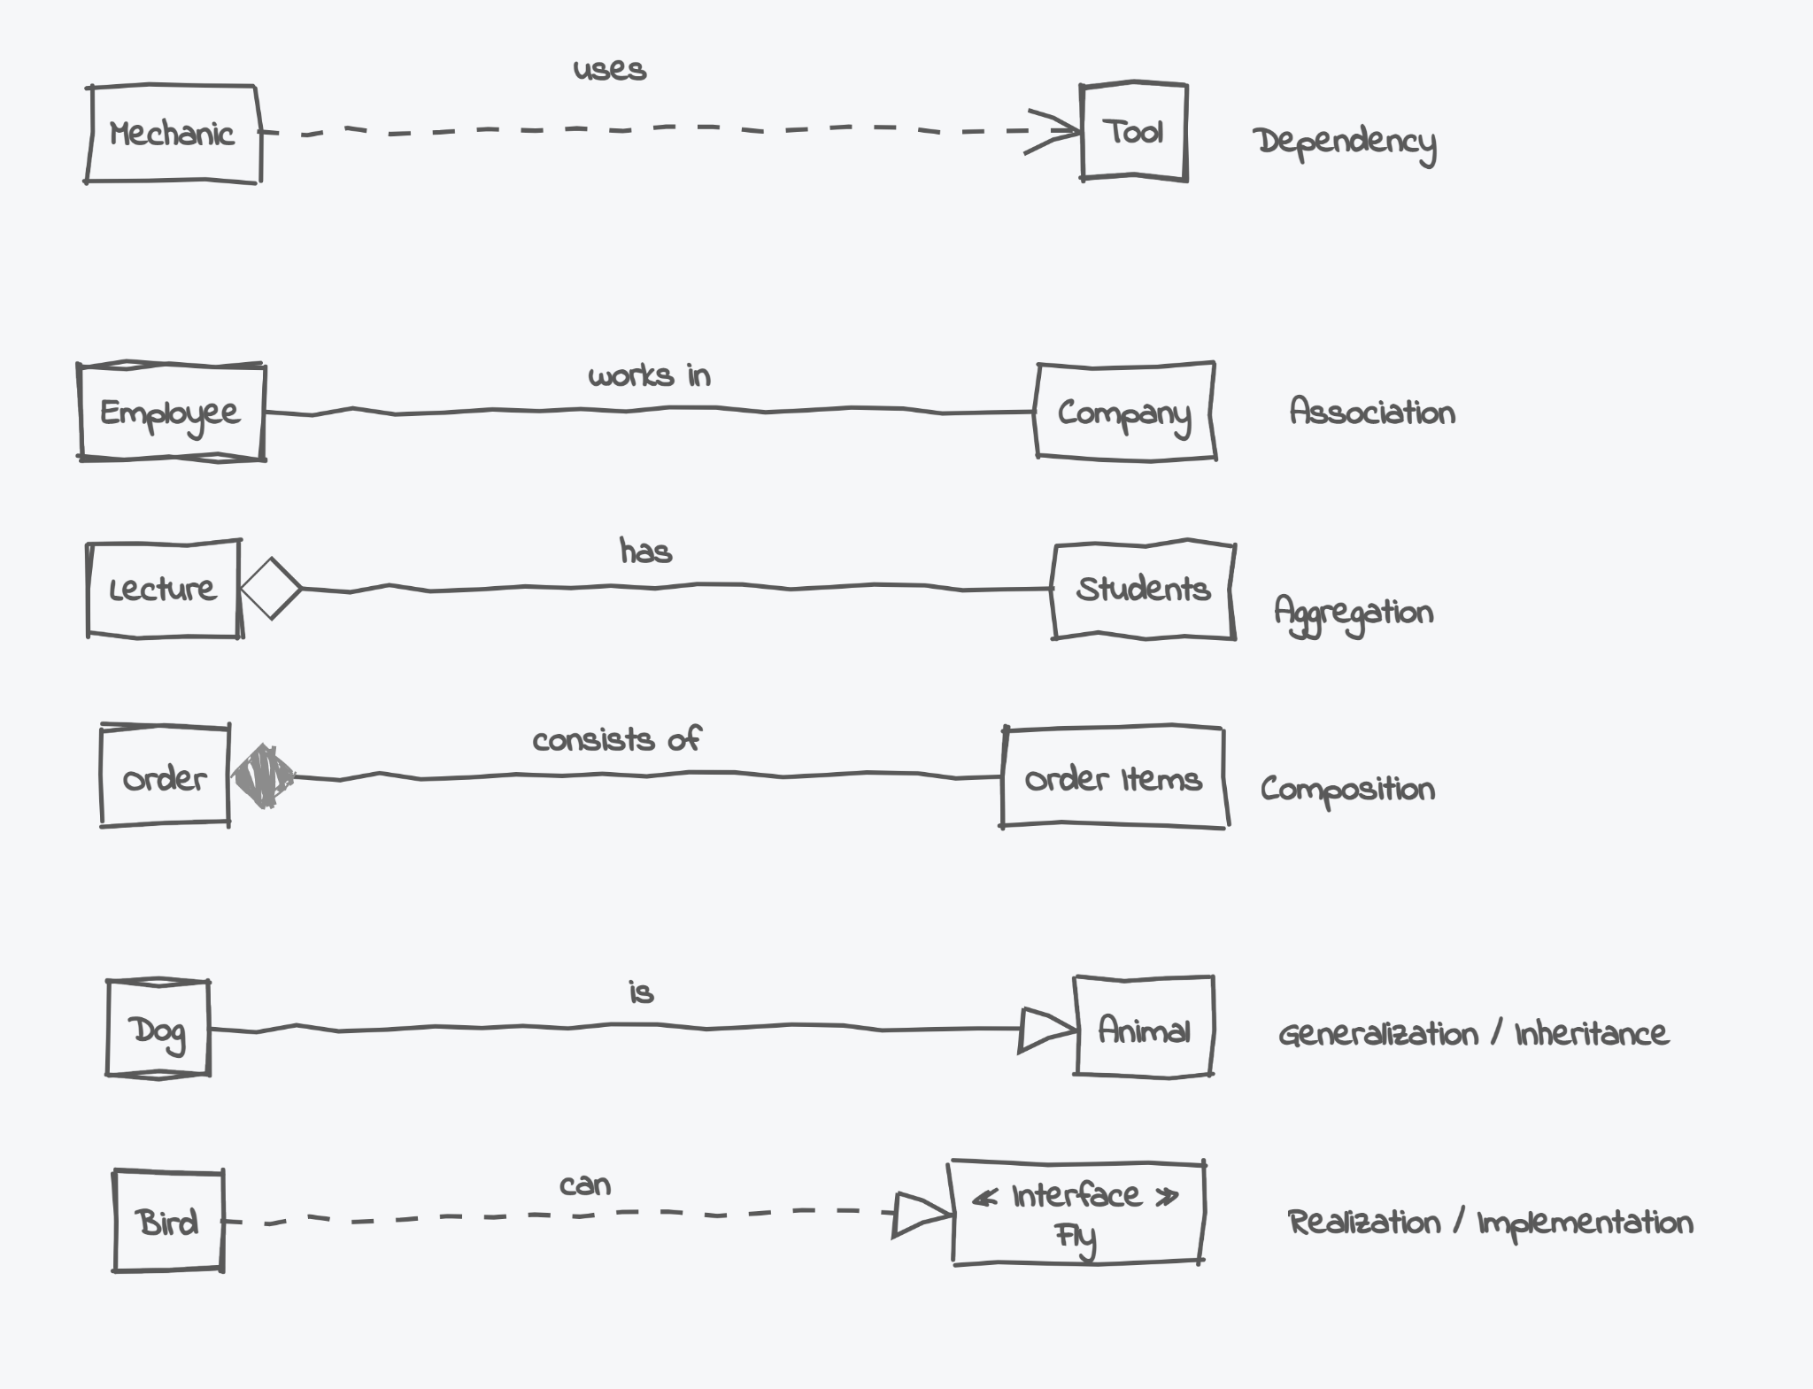
- Exceptions: Exceptions can be modeled like any other class

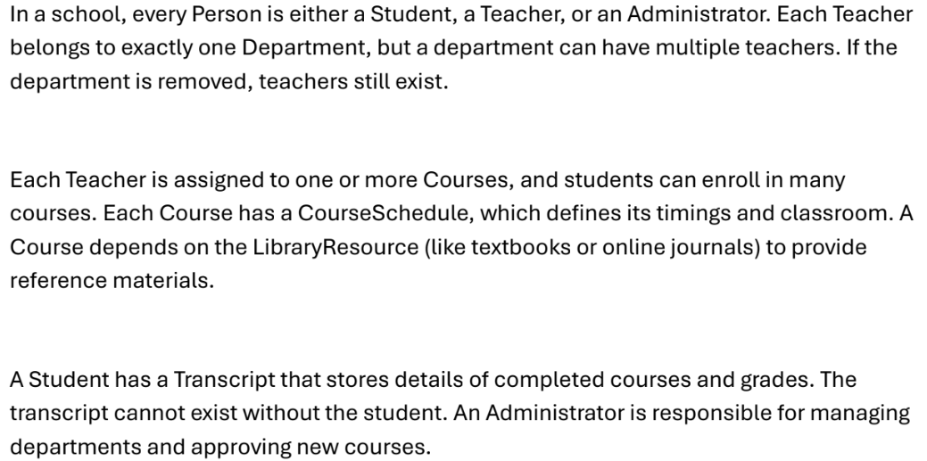
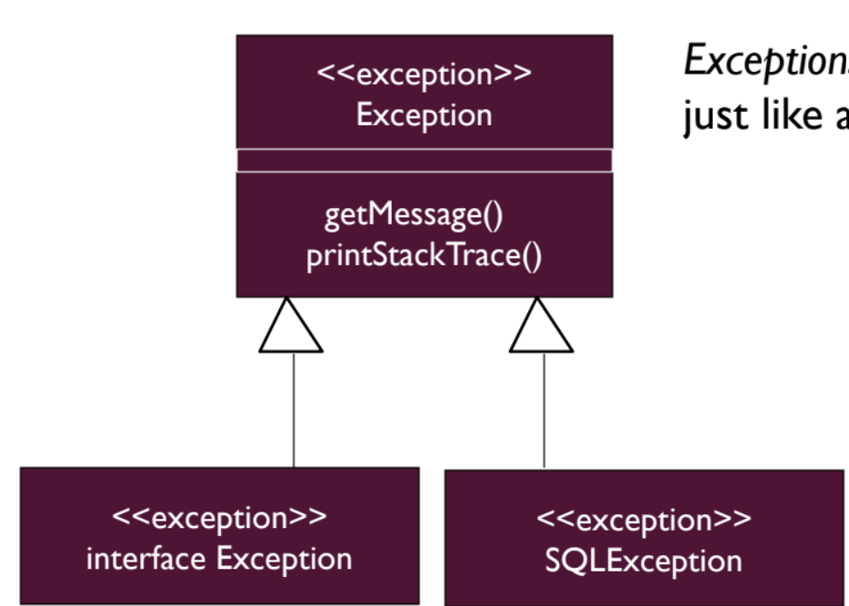
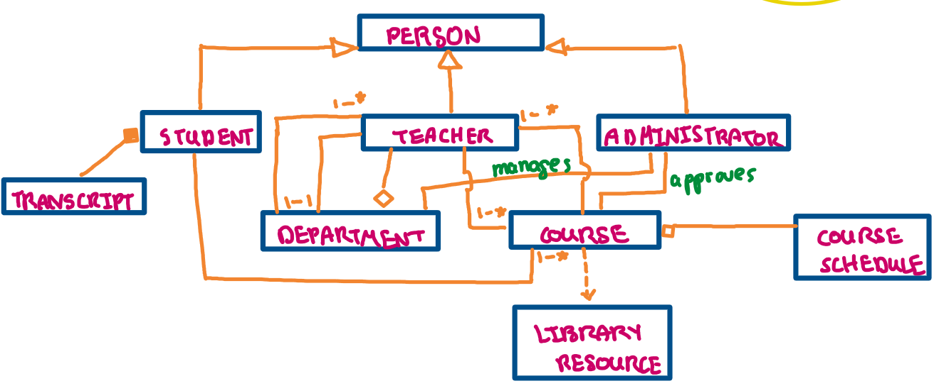
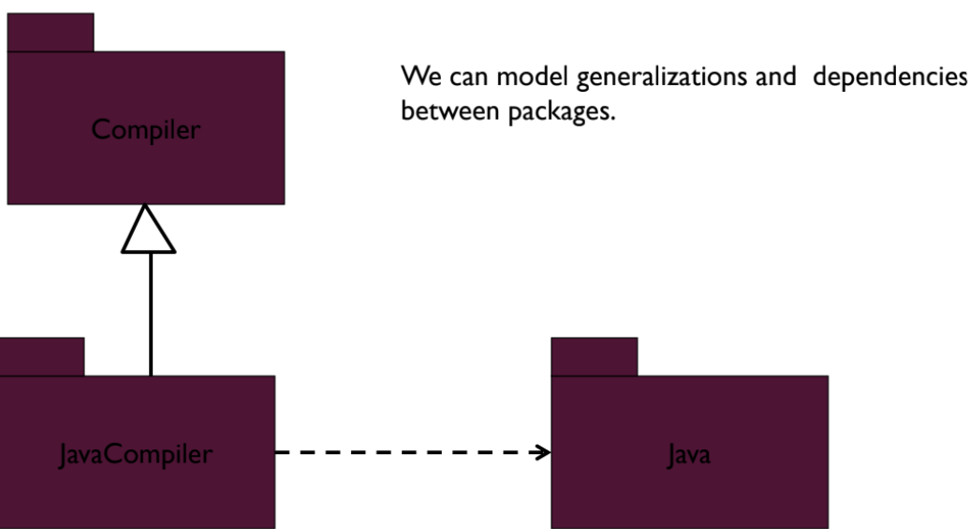
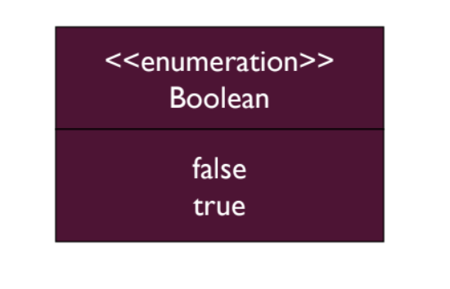\\

- The class depends on the enumeration because it uses it.
- Exception is a class itself (usually inherits from a base exception class).
- Other classes depend on exceptions if they throw or handle them.

POST MID 1 CONTENT
ROBUSTNESS ANALYSIS DIAGRAM
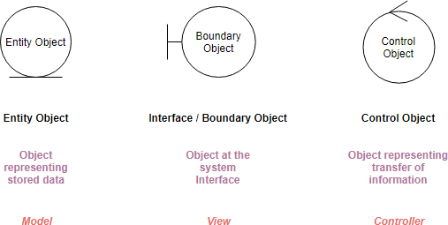
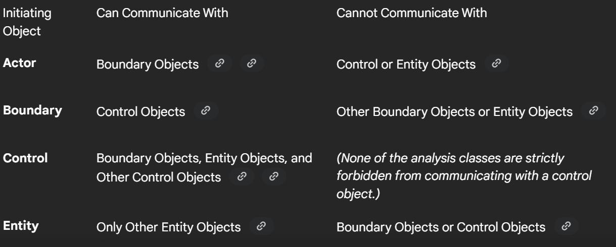
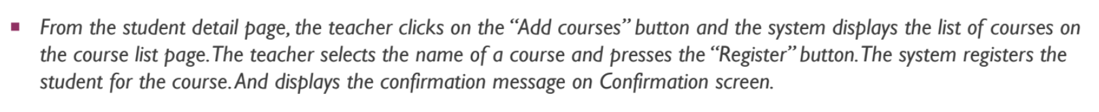
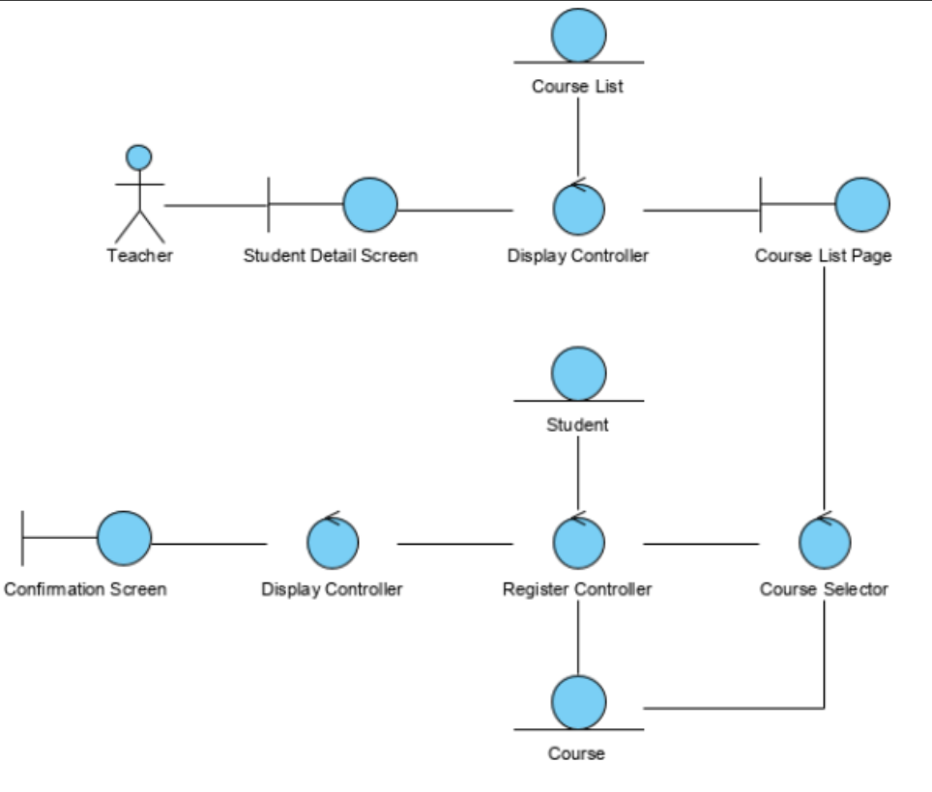
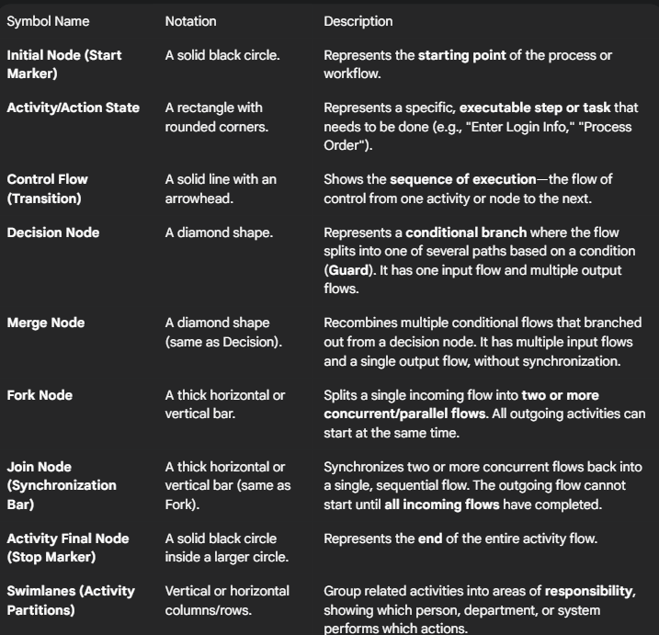
ACTIVITY DIAGRAM
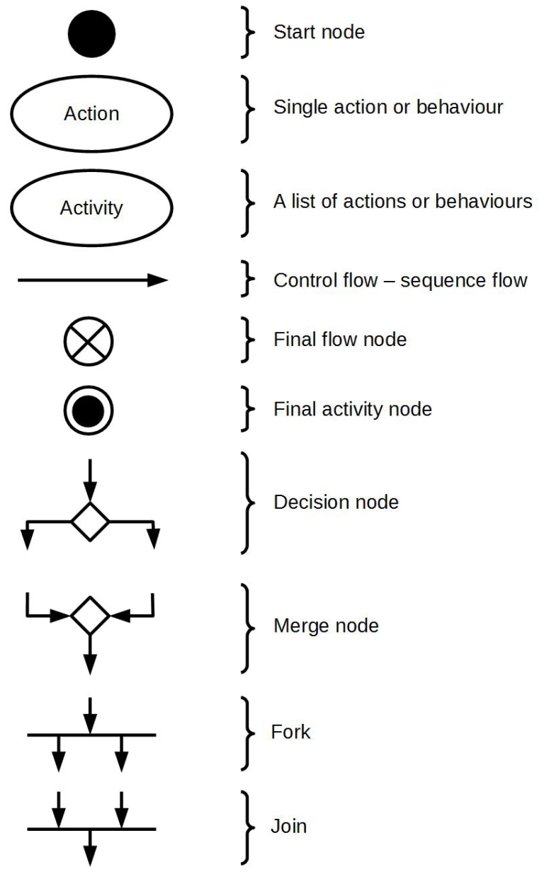

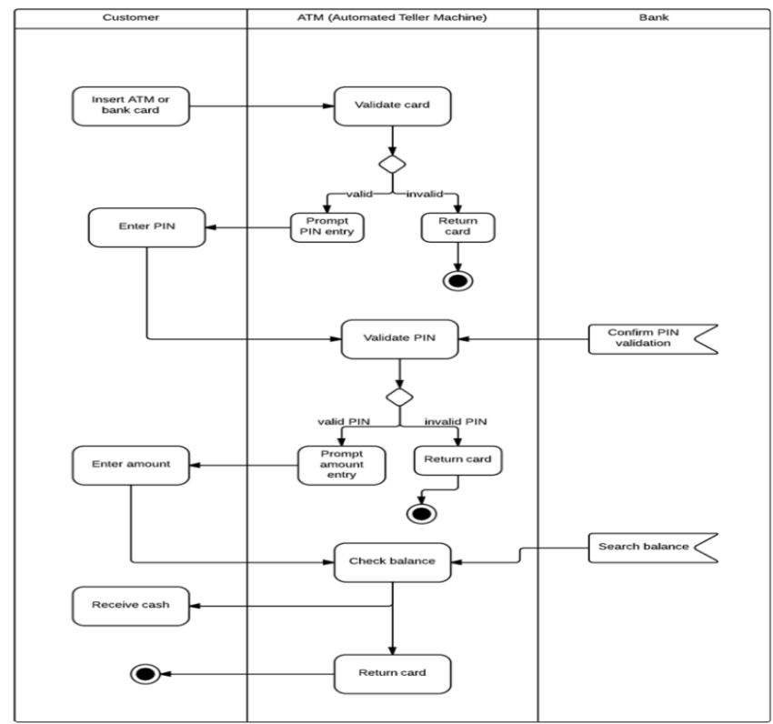

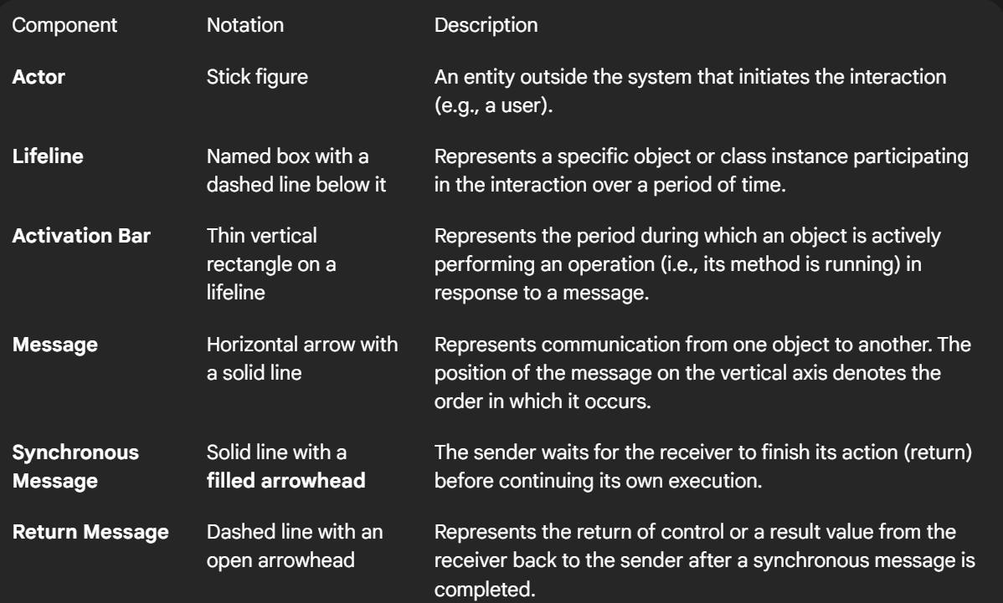
SEQUENCE DIAGRAM
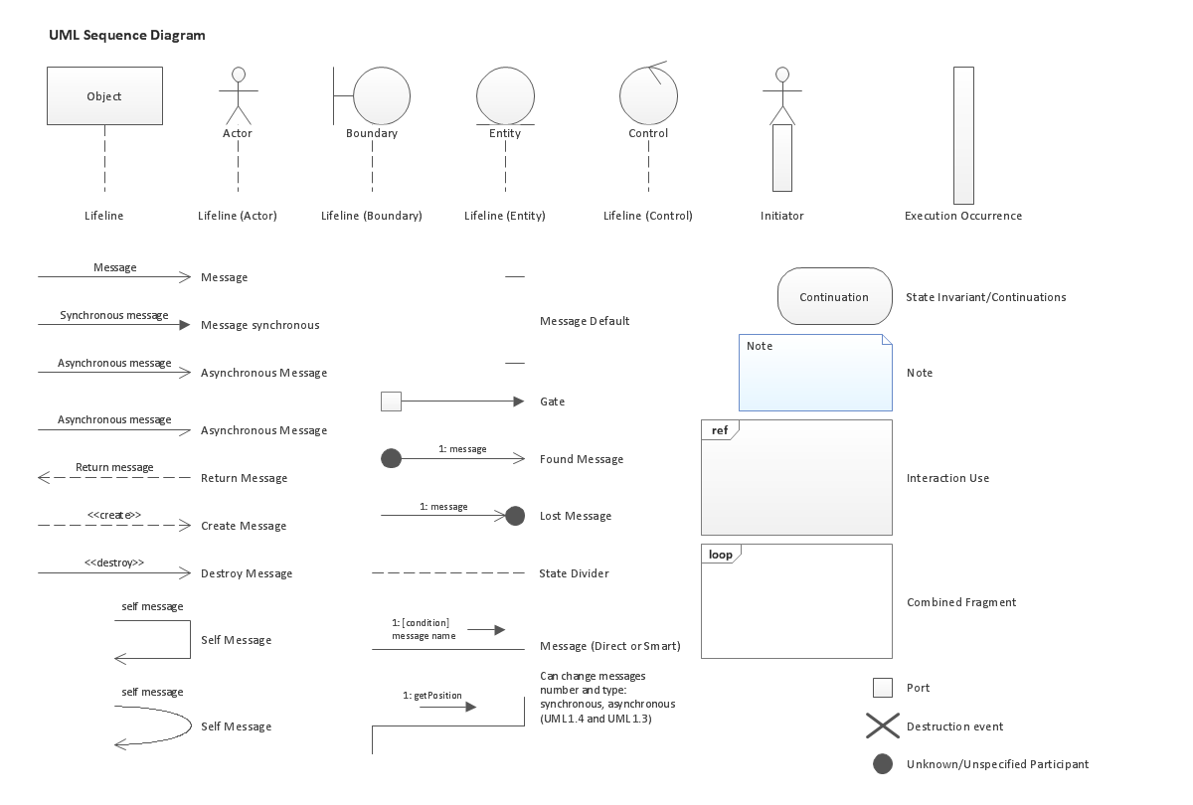
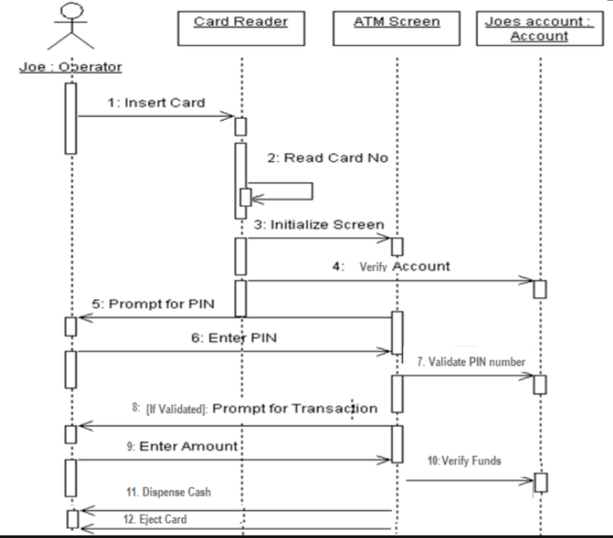
TIMING DIAGRAM
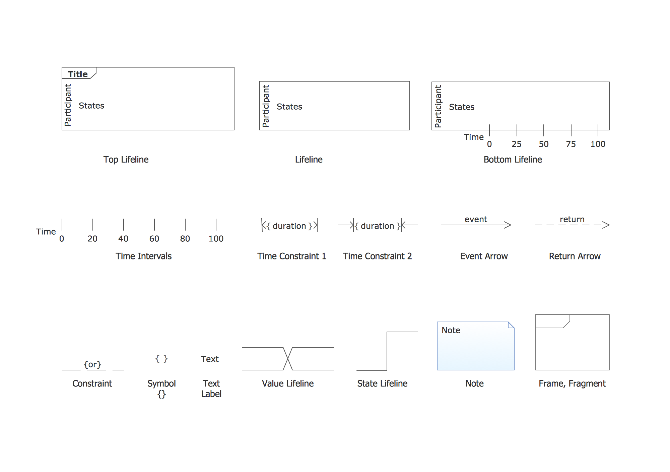
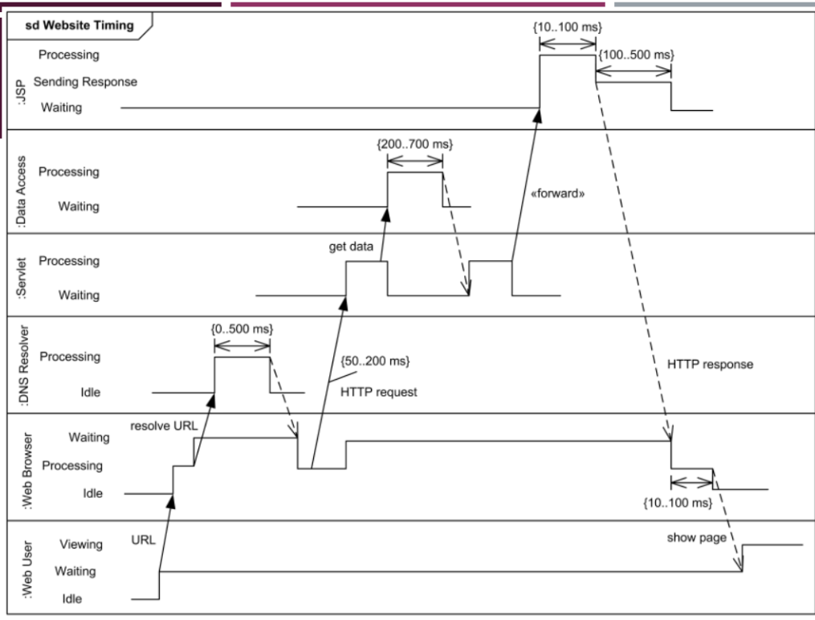

WEEK 5 ROBUSTNESS ANALYSIS AND ECB PATTERN
Topic: Use-Case Realization, Analysis Classes, and Robustness Analysis (ECB Pattern)

1. Use-Case Realization
- Definition: Describes how a particular use case is realized within the Design Model, in terms of collaborating objects.
- Purpose: Converts the use case description into a set of interacting classes/objects.

Diagrams Used
- Interaction Diagrams – Sequence and/or Collaboration Diagrams
→ Describe how the use case is realized in terms of collaborating objects.
- Class Diagrams – Describe the classes participating in the use case realization and their relationships.
📘 They model the context and detailed collaboration of a use-case realization.

2. Role of Designer
- Designer is responsible for the integrity of the use-case realization.
- Coordinates with other class designers to ensure relationships and class responsibilities are correct.
- Each developer may be assigned specific classes.
- Helps determine or refine class responsibilities and interfaces.

3. Analysis Classes – Early Conceptual Model
- Represent an early conceptual model of the system.
- Evolves quickly and remains fluid during early analysis.
- Used to capture required behaviors to explore system structure and behavior.
- Rarely survive intact into implementation — may become subsystems, components, split/combined classes later.

4. Identifying Candidate Classes from Behavior
Three system perspectives to identify classes:
- Boundary – between system and its actors.
- Information – data the system uses.
- Control logic – internal coordination.
Use stereotypes to represent these:
<<boundary>>, <<control>>, <<entity>>
👉 Isolate these 3 areas because they are most likely to change — helps create a robust model.

5. Discovering Classes
- Analysis classes = first draft of object model.
- Represent things in the system that have responsibilities and behaviors.
- Capture:
  - Functional requirements
  - Interface requirements
  - Some control logic
- Viewed from the problem domain perspective.

6. ECB Pattern (Entity-Control-Boundary)

Origin & Purpose
- Refinement of MVC (Model-View-Controller) pattern.
- Introduced by Doug Rosenberg & Kendall Scott.
- Uses UML stereotypes for creating class and interaction diagrams.

6.1 Model–View–Controller (MVC)
- Model: Expresses application’s behavior.
- View: Output representation (UI).
- Controller: Accepts input and converts to commands for Model/View.

6.2 Entity–Control–Boundary (ECB)
Decomposes system into:
- Entity objects – represent core data and business logic.
- Control objects – manage application logic, mediate between entity and boundary.
- Boundary objects – handle communication with external actors/systems.
Difference from MVC: ECB defines explicit communication rules between object types.

7. Boundary Classes
- Definition: Support communication between system’s external environment and internal objects.
- Each user interface or external interface → one boundary class.
- Actors always interact through boundary classes.

Types
- User Interface Classes – Menus, forms, etc.
- System Interface Classes – Communication with external systems (e.g., databases).
- Device Interface Classes – Interaction with devices or sensors.

Guidelines
- Identify boundary classes from use-case flow of events.
- One boundary class per actor/use-case pair (initially).
- Each class coordinates the interaction with the actor.
- GUI systems often have one boundary class per window/dialog.
📘 Notation: <<boundary>> ClassName

8. Control Classes
- Definition: Responsible for application-specific business logic.
- Act as intermediaries between boundary and entity objects.
- Each boundary class communicates with one control class.
- Control class manages flow of execution for each use case.
- Coordinates activities across other control and entity objects.
- Each entity is typically tightly coupled to a control object.
📘 Notation: <<control>> ClassName

9. Entity Classes
- Definition: Represent stores of information within the system.
- Used to model key items the system manages (e.g., Student, Course, Teacher).
- Persistent — exist even after use case ends (DB storage).
- Responsible for storing and managing data.
- Data flows from entity → control → boundary → GUI for display.
📘 Notation: <<entity>> ClassName

Candidate Entity Classes Example
- Course registration system includes:
  - Student, CourseOffering, Schedule
- These are entity classes representing persistent data.
- Note: Modeling an actor’s data (e.g., Student info) ≠ modeling the actor itself.
→ “Student” entity exists independently of the actor role.

10. Analysis Class Summary (in a Nutshell)
Type | Definition / Role | Persistence | Example
Entity | Stores/manages information | Persistent (DB) | Student, Course
Boundary | Interface between actor and system | Temporary | Forms, GUI windows
Control | Handles use-case logic, coordinates entities & boundaries | Exists during use case | RegistrationController
📘 Proposed in: Rational Unified Process (RUP)

11. Analysis Class Diagram
- Definition: UML diagram showing analysis classes and their relationships.
- Purpose: Visualizes initial data and behavior requirements before design details.

12. Communication Rules in ECB Pattern

✅ Allowed Communication
- Boundary → Control
- Control → Entity
- Entity ↔ Control
- Boundary ↔ Actor

🚫 Not Allowed
- Boundary → Entity directly
- Entity → Boundary directly
- Actor → Entity directly
📘 Enforces separation of concerns between UI, logic, and data.

13. Example – Insurance System
- Entity Classes: Insurance Policy, Insurance Contract, Customer, Insurance Company.
- Control Classes: ChangeInsuranceContract, NewInsuranceContract, DeleteInsuranceContract.
- Boundary Classes: SalesWindow, ManagementWindow.
- Control classes serve boundary classes; boundary interacts with actor.

14. Robustness Analysis
- Definition: Process of analyzing use-case text to identify entity, boundary, and control objects (first-guess set).
- Purpose: Ensures completeness and adherence to ECB diagramming rules.
- Used to transition from use-case narrative → object structure.
📘 Notation:
Robustness diagrams use the same stereotypes:
- <<boundary>> (UI or system interface)
- <<control>> (use-case logic)
- <<entity>> (data storage)

15. Robustness Diagram (Example – University Registration System)
Scenario Summary:
- Professors choose courses → Registrar inputs details → Course catalog created.
- Students select desired courses → Advisor verifies eligibility → Registrar registers student.
- Schedule and confirmation generated → Professors receive rosters.
Diagram Elements:
- Actors: Professor, Student, Registrar, Advisor.
- Boundary Classes: CourseCatalogSystem, RegistrationForm, ConfirmationScreen.
- Control Classes: RegistrationController, ScheduleController.
- Entity Classes: Student, Course, Schedule, Professor.
Diagram Notation:
Actor → <<boundary>> → <<control>> → <<entity>>

ACITIVITY DIAGRAMS, SEQUENCE DIAGRAMS, COLLABORATION DIAGRAMS, TIMING DIAGRAMS USE SLIDES

4+1 VIEWS + HOMOGENIZATION

1. What is a Model?
- Definition: A model is an abstraction describing a subset of a system.
It emphasizes essential details and omits irrelevant ones.
- Purpose: Helps understand, design, and communicate existing or future systems.
- Key Point: A model never fully corresponds to reality; it simplifies for understanding.
- Examples: Bridges, buildings, traffic flow, economic policy.

2. Why Do We Need Models?
- Communication: Ensures all stakeholders share a common understanding of requirements.
- Visualization: Presents all relevant facts in an understandable way.
- Verification: Checks completeness, consistency, and correctness of system details.

3. Diagrams vs Models
Diagram | Model
Illustrates some aspect of a system. | Provides a complete view of a system at a certain stage and perspective.
May represent one part. | Usually consists of many related diagrams + supporting documentation.

4. View
- A view represents a specific perspective or projection of a system.
- A system has multiple aspects:
  - Functional: Static structure and dynamic interactions.
  - Non-functional: Timing, reliability, deployment.
  - Organizational: Work distribution, code mapping.
- Each view focuses on one aspect to manage complexity.
- Views are interconnected and together describe the full system.

5. UML Views
Four main UML classification categories:
- Structural classification
- Dynamic behavior
- Physical layout
- Model management

6. Systems, Models, and Views
- Model: Abstraction describing a subset of a system.
- View: Depicts selected aspects of a model.
- Notation: Graphical/textual rules used to depict views.
- Overlap: Models and views can overlap for the same system.
Example:
- System: Aircraft
- Models: Flight simulator, scale model
- Views: Electrical wiring, fuel system, blueprints

7. What is a View Model?
- A view model defines a set of coherent views used to construct a system or software architecture.
- Each view shows the system from the perspective of specific concerns.
- Purpose: To manage complexity of large, distributed systems via viewpoint modeling.

8. Intent of the 4+1 View Model
- Provides a mechanism to separate different aspects of a software system into distinct views.
- Recognizes that different stakeholders have different interests:
  - Developers: Classes, logic (implementation aspects)
  - System administrators: Hardware, deployment, network setup
  - Testers / Managers / Customers: Business functionality and validation

9. How Many Views Are Needed?
- Views should fit the system context:
  - Single processor → Drop deployment view
  - Single process → Drop process view
  - Small programs → Drop implementation view
- Some systems may add extra views (e.g., Data View, Security View).

10. Diagrams in Views
- Each view is composed of one or more diagrams.
- Overlap can exist (a diagram may belong to multiple views).
- Each diagram must:
  - Be simple and clear enough for communication.
  - Remain consistent with other views for a complete picture.
- UML: A multi-diagrammatic language — each diagram is a view into a model and provides a partial representation of the system.

11. The 4+1 View Model
Proposed by Philippe Kruchten (1995) — organizes architecture into five interrelated views.
View | Focus / Purpose | Primary Stakeholders | Diagram Types
1. Use Case View (the “+1”) | Describes system functionality as perceived by external actors. Defines functional requirements. | Customers, Analysts, Testers | Use-case and activity diagrams
2. Logical View | Shows how the system provides functionality. Focuses on structure and collaboration. | Designers, Developers | Class, object, state machine, interaction, activity diagrams
3. Process View | Shows system concurrency, threads, synchronization, and performance aspects. | Developers, Integrators | State machines, activity, interaction, deployment, and timing diagrams
4. Implementation View | Describes software modules, components, and dependencies. Addresses build, versioning, allocation, and progress. | Developers | Component and interaction diagrams
5. Deployment View | Describes physical deployment of hardware and software nodes, and their connections. | Developers, Testers, System Integrators | Deployment diagrams

Why 4 + 1 (and not just 5)?
- The Use-Case View is special — it defines requirements that drive all other views.
- When others are complete, it may seem redundant, but no other view exists without it.

Relation with UML
- The 4+1 approach came before UML, but is fully compatible.
- UML (13 diagrams) can be categorized under the 4+1 views.
- It remains relevant as a conceptual framework for organizing models.

Importance of the 4+1 Model
- Simplifies modeling with better organization and separation of concerns.
- Enables stakeholders to focus on relevant parts.
- Helps architects prioritize modeling concerns and communicate effectively.

12. Homogenization of the System
- Definition: To make the model consistent and uniform across teams; blending elements into a homogeneous whole.
- In large projects, multiple teams may model similar things using different names or words — homogenization ensures unity and consistency.

Why Homogenize?
- Multiple teams = multiple interpretations → must standardize terminology and structure.
- Prevents inconsistent or redundant modeling.
- Should be an ongoing process throughout development — not left to the end.
- Requires continuous communication among teams (meetings, reviews).

Elements of Homogenization
- Combining Classes
- Splitting Classes
- Eliminating Classes
- Consistency Checking
- Scenario Walk-Through
- Event Tracing
- Documentation Review

13. Combining Classes
- Different teams may name similar classes differently → resolve naming conflicts.
- Conduct model walkthroughs to identify duplicates.
- Choose the name closest to customer’s language.
- Pay attention to control classes — one per use case may be excessive; merge those with similar sequencing logic.
Example:
- MaintainCourseInfoControl and CreateCourseCatalogControl → combined into one since both handle course information similarly.

14. Splitting Classes
- Each class should do one thing well (high cohesion).
- If a class handles multiple unrelated responsibilities, split it.
Example 1:
StudentInformation (includes both personal data and course history) → split into StudentInformation and Transcript.
Example 2:
Initially, Course had an attribute Department.
Later found department had its own behavior (e.g., tracking courses, professors, students).
→ Created a separate Department class and replaced the attribute with an association between Course and Department.

15. Eliminating Classes
- Remove classes that:
  - Lack structure or behavior.
  - Don’t participate in any use case.
  - Act as pass-through control classes (no sequencing logic).
Example:
- SelectCoursesToTeachControl receives info and directly passes it to entity class Professor — no sequencing logic → can be eliminated.

16. Consistency Checking
- Ensures static (class diagrams) and dynamic (use case, interaction) views align.
- Must occur continuously throughout development, not as a one-time step.
- Conducted by a small cross-functional team (analysts, designers, domain experts, testers, and customer reps).

17. Scenario Walk-Through
- Validate high-risk scenarios (sequence/collaboration diagrams).
- For each message, confirm:
  - It’s defined as an operation on the class.
  - Communicating objects are linked via association or aggregation.
- Check reflexive relationships (when multiple objects of the same class interact).
- Each class on a diagram should:
  - Appear in at least one scenario.
  - Have operations used or justified for completeness.

18. Event Tracing
- For every message in sequence or collaboration diagrams:
  - Confirm the sender operation triggers the event.
  - Confirm the receiver operation handles it.
  - Ensure association/aggregation exists between sender and receiver.
  - Verify corresponding state transitions are present in the class’s state diagram.

19. Documentation Review
- Every class must be documented with:
  - Unique name.
  - Complete definition of attributes and operations.
  - Conformance to project standards, format, and content rules.
- Ensures clarity, consistency, and maintainability.

DESIGN PATTERNS

I. Introduction to Design Patterns
- Definition: A general reusable solution to a commonly occurring problem in software design.
- Nature: It is not a finished design that can be transformed directly into code; rather, it is a description or template for how to solve a problem.
- Core Concept: It is a "recurring solution to a standard problem, in a context."
- Christopher Alexander’s Quote: "A pattern describes a problem which occurs over and over again... and then describes the core of the solution... so you can use this solution a million times over, without ever doing it the same way twice."

II. The Need for Design Patterns
- Efficiency: Helps designers get to the right design faster.
- Standardization: Provides a standard solution to common programming problems and a shared lingo/library for developers.
- Flexibility: Makes code meet certain criteria to ensure it is more flexible.
- Abstraction: Provides names for abstractions above the class and object level.
- Reuse: Engineering disciplines use handbooks; patterns allow software engineers to reuse architecture and design, which is otherwise expensive to develop from scratch.

III. Evolution & The Gang of Four (GoF)
- The "Gang of Four": Erich Gamma, Richard Helm, Ralph Johnson, and John Vlissides.
- The Book (1995): Design Patterns: Elements of Reusable Object-Oriented Software.
  - Part 1: Pros and cons of Object-Oriented Programming (OOP).
  - Part 2: Catalog of 23 design patterns in C++ and Smalltalk.

IV. The Three Types of Design Patterns
- Creational: Deal with object creation and initialization while hiding creation logic. (e.g., Singleton, Factory, Builder).
- Structural: Deal with how classes and objects are combined to form larger structures and identify relationships between entities. (e.g., Adapter, Bridge, Facade).
- Behavioral: Used in communications between entities to make them easier and more flexible to interact. (e.g., Observer, Strategy, Command).

V. Factory Pattern (Creational)
- Intent: "Define an interface for creating an object, but let subclasses decide which class to instantiate." It lets a class defer instantiation to subclasses at run time.
- AKA: Virtual Constructor.
- Motivation/Applicability:
  - When a class cannot anticipate the class of objects it must create.
  - When a class wants its subclasses to specify the objects it creates.
  - When responsibilities are delegated to helper subclasses and you want to localize knowledge of which helper is the delegate.
- Participants:
  - Product: Defines the interface of objects created.
  - ConcreteProduct: Implements the Product interface.
  - Creator: Declares the factory method; relies on subclasses for the implementation.
  - ConcreteCreator: Overrides the factory method to return a ConcreteProduct instance.
- Implementation Example (Shapes):
  - Create a Shape interface with a draw() method.
  - Create concrete classes (Circle, Square, Rectangle) implementing Shape.
  - Create a ShapeFactory class with a getShape(String type) method.
  - Client calls getShape("CIRCLE") to receive a Circle object cast as a Shape.

VI. Adapter Pattern (Structural)
- Intent: Convert the interface of a class into another interface that clients expect. It allows classes to work together that couldn't otherwise because of incompatible interfaces.
- AKA: Wrapper Pattern.
- Motivation:
  - When you have an "off the shelf" component or library whose "view of the world" is incompatible with your system.
  - When you cannot change the library interface because you lack source code or want to keep it domain-independent.
- Components:
  - Adaptee: The existing interface that needs adapting.
  - Target: The domain-specific interface the client uses.
  - Adapter: Implements the Target interface and connects the Adaptee to the Client.
  - Client: Interacts with the Target interface.
- Class vs. Object Adapter:
  - Class Adapter: Uses inheritance; can only wrap a class; allows overriding Adaptee behavior.
  - Object Adapter: Uses composition; can wrap both classes and interfaces; harder to override behavior but can work with multiple subclasses of Adaptees at once.
- Implementation Example (Media Player):
  - AudioPlayer (Client) expects MediaPlayer interface (plays MP3).
  - VlcPlayer (Adaptee) has a different interface (plays VLC).
  - MediaAdapter (Adapter) implements MediaPlayer and wraps an instance of AdvancedMediaPlayer (the Adaptee) to translate play() calls into playVlc() calls.

Summary of When to Use Adapter:
- Using third-party code that is incompatible with client code.
- Using existing code with extended functionality without changing the original code.
- When requiring multiple inheritance (via Object Adapter) or wrapping sealed classes.

